# Creating Actors

Start by creating an actor. Under the “Actor” tab, click add. For the name, type “Bob”. Now let’s fill in the stats. We want Bob to start out with 10 health points (HP) and get 5 more on each level up. He should start out with 3 skill points (SP) and get 2 more on each level up. We will say he needs 4 experience points (XP) to level up. Fill in that information as shown below.

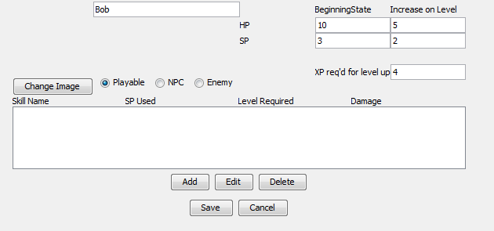

Now let’s select a sprite sheet for Bob. Click the change image button and select a file. 

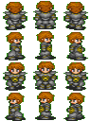The sprite sheet you use should be 96x128 with 3 sprites facing each direction, like this one.

Note, the first row has the sprite facing backwards, the 2nd right, 3rd forward, 4th left. If the sprite sheet you choose is set up differently, the sprite won’t display correctly in the game.

Once you’ve selected your sprite sheet, it will be displayed next to the actor name. Now let’s give Bob some skills.

## Creating Skills

Click the add button and a skill editor window will pop up.

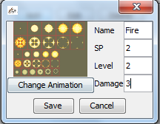We will create the skill fire. We need to specify a name for the skill, the SP and Level required to use the skill, and the damage it does to the victims HP. Fill in the information as shown below, and click “Change Animation” to select an image for the skill.

Click save and the skill will be added to Bob’s skill list

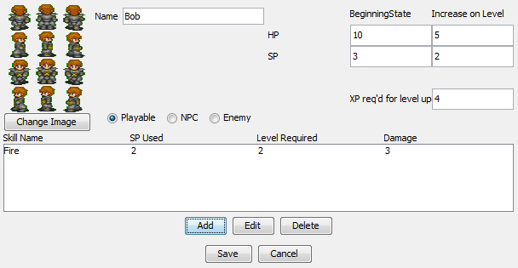

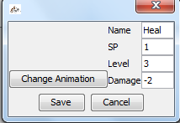You can also create skills that help other actors instead of hurting them. Let’s give Bob healing powers. Click the add button again. Fill in the information as shown. Negative damage means the skill will increase the HP of whoever the skill is used on.

Click save for the skill and save for the actor. Bob now shows up in your list of Actors.

